A designer is often faced with ethical decisions. Ethical considerations in design relate mainly to intellectual property, accessibility, and the sustainability of your practices. Intellectual property concerns ensure that creative practitioners respect the rights of other creators, clients, and relevant stakeholders. Accessibility governs the rights of diverse audiences to access your designs, and finally, sustainability, acts as a guidepost for designers to act responsibly towards their environment.

## Ownership

The first ethical standard in design that you are responsible for upholding, relates to ownership, copyright, and intellectual property. These standards are crucial for ensuring that designers respect the rights of creators, clients, and other stakeholders when it comes to their designs.

Definitions:

* **Copyright** is a form of legal protection granted to the creators of any original artistic work also known as work of authorship. It gives the creator exclusive rights to reproduce, distribute, perform, display, and licence their work. It gives creative professionals exclusive rights to their work and allows them to control its use, reproduction, and distribution.
* **Intellectual Property (IP)** is a broad term that encompasses various legal rights associated with intangible assets and creations of the mind, including copyrights, trademarks and patents.
* **A trademark** isa distinctive sign, symbol, word, or phrase used to identify and distinguish the goods or services of one party from those of others, e.g. brand names, slogans, symbols, etc. Unlike copyright, which protects original creative works, trademarks protect brands and the distinctive elements that identify and differentiate them from competitors.

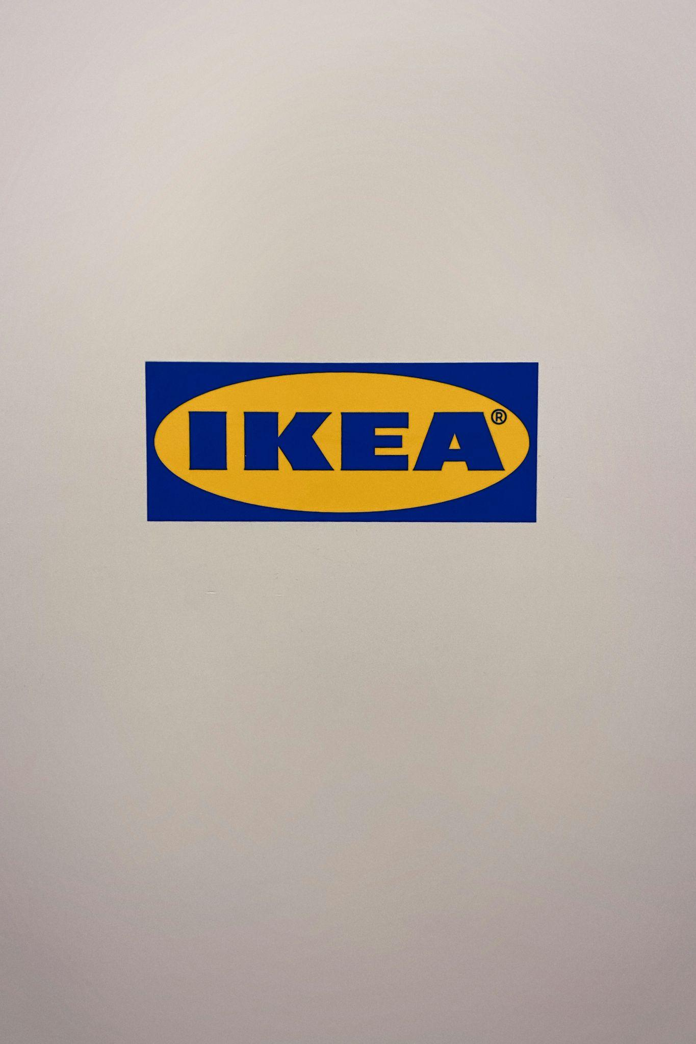

Fig 1. Unsplash (n.d.) The ‘R’ symbol signifying the registered trademark of Ikea logo

### Respect for copyright

Copyright protects the expression of ideas rather than the ideas themselves. It covers forms of expression such as books, articles, designs, paintings, photographs, music compositions, and computer software. Creative practitioners have an ethical responsibility to respect the copyright of original works created by others. Such works may include any illustrations, photographs, images, fonts, logos, and other design elements that are protected by copyright law. Before using it, you should first obtain proper permissions or licences for the copyrighted materials, and ensure that you abide by any limitations/guidelines imposed on you through its use. For example, some stock images can be legally used except for commercial purposes. Other images may be used, but only in its original forms, i.e. not edited/modified in any way.



Fig 2. Pixabay (n.d.) Using copyrighted material without permission is equivalent to stealing

### Originality and attribution

Designers should strive to create original work that are not copied or plagiarised from existing designs or other sources. Your work should avoid reproducing or modifying copyrighted works without permission and give proper attribution to the original creators when necessary, e.g. through proper citing and/or referencing.

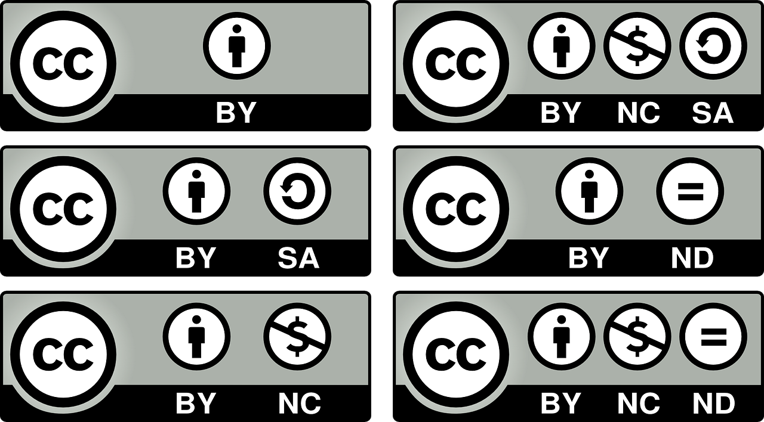

Fig 3. Pixabay (n.d.) Creative Commons restrictions

### Respect for intellectual property

As a designer, you should always respect the intellectual property rights of others and refrain from using unauthorised trademarks, logos, brand assets, or established materials in your work. You are encouraged to do thorough research to ensure that your designs do not infringe upon existing trademarks or violate the rights of trademark owners.

### Fair compensation and recognition

Designers have an ethical obligation to seek fair compensation for their work and advocate for their rights as creative practitioners (e.g. seek attribution), which can be especially daunting when you’re starting out as a designer. Still, do not shy away from negotiating fair payment terms, royalties, or licensing fees that reflect the value of your creative contributions, skill, and experience.



Fig 4. Unsplash screenshot (2024) An example of compensation sought for certain images

### Education and advocacy

When working with clients, stakeholders, other designers, or the public, it is your ethical responsibility to educate them on copyright laws, intellectual property rights, and ethical considerations in the creative industry. As a designer, you should advocate for ethical practices, transparency, and accountability within the industry and try to uphold its integrity and reputation.

## Accessibility and Protected Characteristics

Ethics related to accessibility and protected characteristics in design ensure that creative works are inclusive, equitable, and accessible to audiences of all abilities and backgrounds. By considering the different needs, preferences, and characteristics of individuals and groups, you can create designs that are respectful, inclusive, and barrier-free.

Designers should adhere to accessibility standards and guidelines, such as the Web Content Accessibility Guidelines (WCAG), where applicable. By following these guidelines, you ensure that your work, if published online, are accessible to a broad audience, including individuals with disabilities. This may provide alternative text for images, ensuring colour contrasts for better legibility, or using keyboard accessibility for navigation, among others.

As a rule of thumb, you should ideally aim to represent diversity in your designs such as making associations with various ethnicity, race, gender, sexual orientation, age, ability, and socio-economic backgrounds. In photography, this might mean including models in your photography work for a product that represent diverse cultures and ethnicities. In fashion, you might be tasked to design a clothing line for a company. You should thus consider where it will be launched and the wider community of people that will have access to the products. This way, you can ensure that the clothing design includes, for example, shorter and longer sleeve variations for those who require more conservative attire. If you are designing a public space, you would aim to design it in a way that allow access to people of all ages and physical abilities. For instance, making the space barrier-free, including elevators in a multi-storey building, or simply providing wider entry ways.



Fig 5. Pexels (n.d.) Representation is important in design

Not only should you represent diversity, but design imagery and messaging must be done accurately and fairly, avoiding stereotypes, biases, or tokenism. This approach demonstrates your cultural sensitivity and awareness as a designer, and exhibits evidence that you respect cultural values, and traditions of diverse communities. Ultimately, these traits will serve you well as a working designer in the industry.

To test biases as well as the effectiveness of your designs, it is vital to conduct user testing with a diverse group of users, including individuals with disabilities and people from different demographics. This will allow you to gather constructive feedback and insights on the accessibility and usability of your designs which could prompt further modifications and improvements.

### About regulators

Besides the designers themselves, the broader custodians of ownership and accessibility are regulators. Regulators are professional bodies that govern the ethical conduct and responsibilities of practitioners within a profession. While there may not be specific regulatory bodies for design industries in the same way as there are for professions like medicine or law, there are professional organisations, industry standards, and legal regulations that influence ethical considerations used in areas of design.

Here are a few examples of professional bodies that play a role in promoting the ethical standards within the design industry:

* Society of British & International Interior Design (SBID)
* International Textile and Apparel Association (ITAA)
* Photography Ethics Centre (photoethics.org)
* International Council of Design (ico-D)

In some countries, media regulators may impose regulations or guidelines governing the content, advertising, and visual communications disseminated by designers. This can be work streamed through various media channels, including print, broadcast, and digital media.

As a designer, it is your responsibility to comply with such regulations, whether they relate to advertising standards, consumer protection, or obscenity laws. It is the role of media regulators to ensure that visuals are ethical, truthful, and compliant with relevant laws and regulations.

Another avenue of regulation has to do with censorship and intellectual property laws. Censorship laws and regulations may impact the content and visual elements that you can legally include in your work, particularly if it involves sensitive or controversial topics. It is vital that you familiarise yourself with such laws so that you are able to navigate these restrictions while still effectively communicating the intended message. You also need to be familiar with intellectual property laws and regulations and adhere to them. These regulations govern the rights and protections of the creators of original works. You need to respect the intellectual property rights of others and adhere to copyright, trademark, and licensing requirements when using third-party assets in your designs. This includes obtaining proper permissions, licences, or releases for any copyrighted materials used in your work.

## Sustainability

Sustainability in design involves integrating environmental considerations into the design process to minimise the negative impacts placed on the environment - whether intentional or unintentional. The aim for all designers and the industry as a whole, should be to promote sustainable practices.



Fig 6. Unsplash (n.d.) Multi-use bags, like canvas totes, have become popular over the years for it sustainability

### Energy consumption and carbon footprint

Creative professionals can reduce energy consumption and carbon footprint by adopting eco-friendly practices, including using energy-efficient equipment and devices (e.g. computers and printers), recyclable materials, and optimising energy settings to minimise power consumption. You can also reduce carbon emissions that come as a result of transportation, by minimising travelling and commuting.

Even before Covid, designers were already opting to work remotely, and this way of working seems to be here for the long haul. If you land a job that is office-based, choosing more eco-friendly transport options would be ideal, like carpooling, cycling, or walking.

### Sustainable sources

You are encouraged to do your research when it comes to suppliers. Materials and resources have a profound impact on the environment and it is your responsibility to source suppliers that make use of more sustainable and environmentally friendly practices. This includes using recycled or FSC-certified paper, eco-friendly inks, and other sustainable materials for print projects, as well as choosing digital tools and software that prioritise energy efficiency and sustainability. In interior- or fashion design, you should choose eco-friendly and sustainable materials. Opt for renewable materials like bamboo, cork, and reclaimed wood, as well as materials with low environmental impact, for a particular space. For fashion collections, choose sustainable and eco-friendly materials such as organic cotton, hemp, bamboo, recycled polyester, and Tencel.



Fig 7. Pexels (n.d.) Bambook furniture in a commercial space

### 

### Product lifecycle and disposal/recyclability

Creative practitioners should consider the entire lifecycle of a design project, from conception to disposal. This can contribute to minimising the environmental impact while maximising sustainability. Design with durability and longevity in mind, using materials and production processes that minimise waste and pollution, as well as considering end-of-life options for disposal or recycling.

### Summary: Six R’s of sustainability

The following six R’s of sustainability is a helpful guide to steer you towards making better, more responsible decisions as a graphic designer:

* **Rethink:** You need to be conscious and carefully weigh each decision in the design process that might have an impact on the environment. Critical thinking is key.
* **Refuse:** Ask yourself whether these products and materials are responsibly and sustainably produced. If not, can you refuse to use them and consider more environmentally responsible alternatives?
* **Repair:** When a material or product is damaged, your main course of action should be to try and repair it rather than replace it.
* **Reduce:** Carefully consider quantities of materials and products with a view to minimising waste.
* **Reuse**: Where possible, give new life to existing materials and equipment, rather than replacing them.
* **Recycle:** If it’s not possible to rethink, refuse, repair, reduce or reuse, then the possibility for recycling the products and the materials when they reach the end of their life cycle should be the main focus of your design development.

These six elements have become a manifesto for the modern way of living and it is calling on us to take measures that help support more sustainable living.